Model My Watershed Activity
In this activity, you will use the Model My Watershed program to explore data layers, simulate the effects of land changes, and propose a project to improve river health.
https://modelmywatershed.org/
Select Area:
- Open Model My Watershed, and hit “Get Started”
Find and zoom into the San Luis Valley
Find “Layers” at the bottom of the screen, click on “Streams,” select Continental US Stream Network

Your screen should look like this:
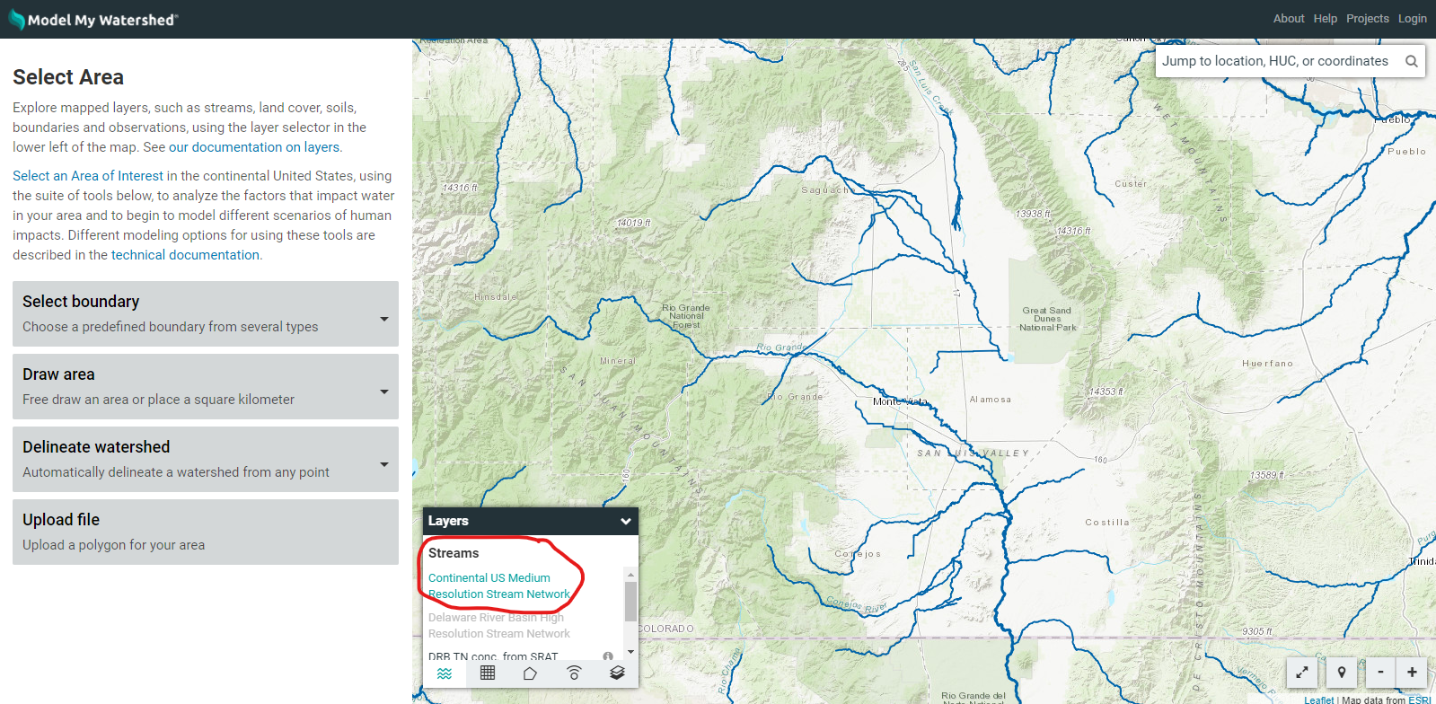

*Zoom in and out to see different rivers and tributaries

- Select a watershed or subwatershed
Click “select boundaries’
Select any of the first three options (USGS units.) This will determine the size and scale of your study area.
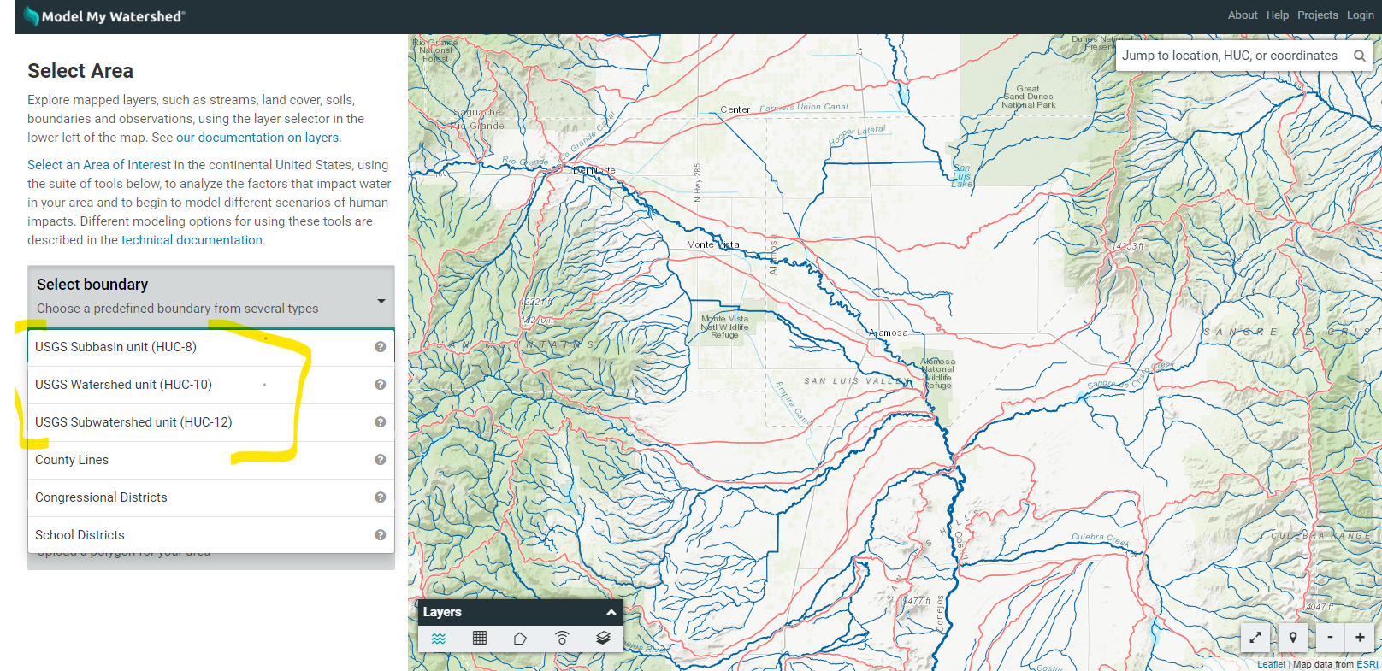
Select any of the rivers in red, and it will create a watershed boundary based on the river segment you clicked on.
Analyze:
Once you have selected a boundary explore the different layers and sidebar tabs to answer the following questions
Under the Layers tab, select Coverage Grid and click on a layer title to turn it one. (click on the to see the legend)
Click the tabs (in yellow) on the side bar to see the percent composition of each layer

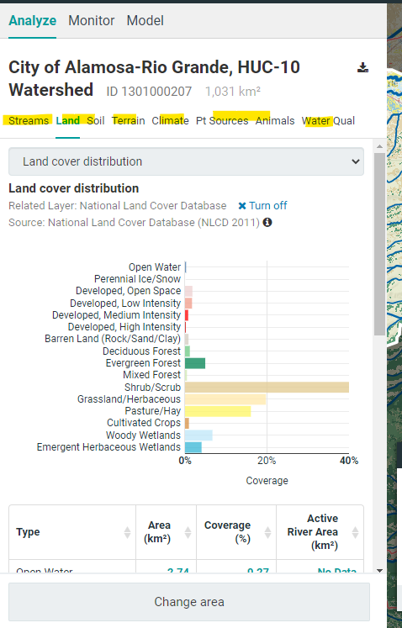

Make sure layer is turned on.

Name of your selected water boundary ____Click or tap here to enter text.___________ (i.e Alamosa River Watershed)

Land Cover: List the top 3 land cover categories and the percentage of the land they cover.
- Click or tap here to enter text.
- Click or tap here to enter text.
- Click or tap here to enter text.

Soil:
Describe where the highest infiltration soil and the slowest infiltration soil is located on the map. (is it closer to rivers, in lower or higher elevations?)
Click or tap here to enter text.

Why do you think that is?
Click or tap here to enter text.

How would slow infiltration affect runoff after snow or rain?
Click or tap here to enter text.

Elevation:
What is the elevation change within your boundary? (highest elevation-lowest elevation)
Click or tap here to enter text.

Climate:
What month or months does your region receive the most moisture?
Click or tap here to enter text.
What areas on your map receive the most moisture?
Click or tap here to enter text.

Animals:
What is the most common livestock?
Click or tap here to enter text.

Model

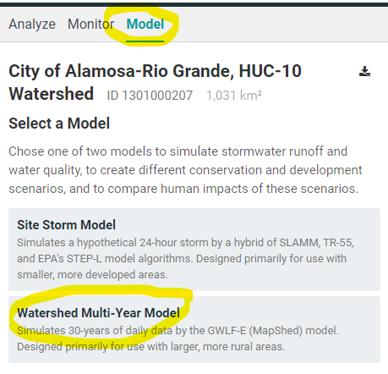
- Click on the “Model” tab and then“Watershed Multi-Year Model”

Answers these questions based on Hydrology Data:

What months is the streamflow the highest?
Click or tap here to enter text.
What months is surface runoff the highest?
Click or tap here to enter text.
What months is subsurface flow the highest?
Click or tap here to enter text.
How are these different or similar to the time of precipitation?
Click or tap here to enter text.

Why might runoff and streamflow be different than the timing of precipitation in your area?
Click or tap here to enter text.

When is ET (Evapotranspiration) the greatest? Evapotranspiration is water transpired by plants that is lost to the atmosphere
Click or tap here to enter text.

Answer these questions based on Water Quality Data

Briefly define each of these terms as water pollutants (use the internet if you need to). Hint: search “Nitrogen as a water pollutant.”
Sediment: Click or tap here to enter text.
Nitrogen: Click or tap here to enter text.
Phosphorus: Click or tap here to enter text.

According to the table, what are the largest contributors for each containment?

Sediment: 1.Click or tap here to enter text.
2.Click or tap here to enter text.

Nitrogen: 1.Click or tap here to enter text.
2.Click or tap here to enter text.

Phosphoros: 1.Click or tap here to enter text.
2.Click or tap here to enter text.

Based on this data, what would you say is the biggest water quality issue for your watershed area?
Click or tap here to enter text.

Add Changes to Your Area
Now you will manipulate the map and compare the changes to hydrology and water quality.

- Click the “Add changes to this area”
Select Land Cover:
Let's say a forest fire happened in your area, triple the area of “Barren areas,” and subtract the difference from “Wooded Areas” so the total area remains the same. Click save
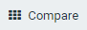
Click and toggle between the different graphs.

What differences did you see between the current condition and the scenarios? Why do you think these changes happened?
Click or tap here to enter text.

What do you think are the impacts of a forest fire on a watershed?
Click or tap here to enter text.

*deleted changes before moving on

- Click on Conservation Practices.

Select “cover crops” and increase cover crop area to half the total agriculture area, exit out and compare.

What water quality impacts did cover crops have? Why do you think cover crops made a difference?
Click or tap here to enter text.

Now go back to conservation practices, and this time increase stream stabilization. What effect did it have on water quality or hydrology? (Be sure to erase previous changes)
Click or tap here to enter text.

Project Proposal
Try out several different conservation practices or combinations of multiple practices. Propose a project that implements conservation practices or alters land cover to improve watershed health. Describe your proposal as you would to funders; what issues does it address, what will you need for implementation? What outcomes do you expect based on the data you generated? Are there other outcomes not predicted in this model that this project will address?
Click or tap here to enter text.

