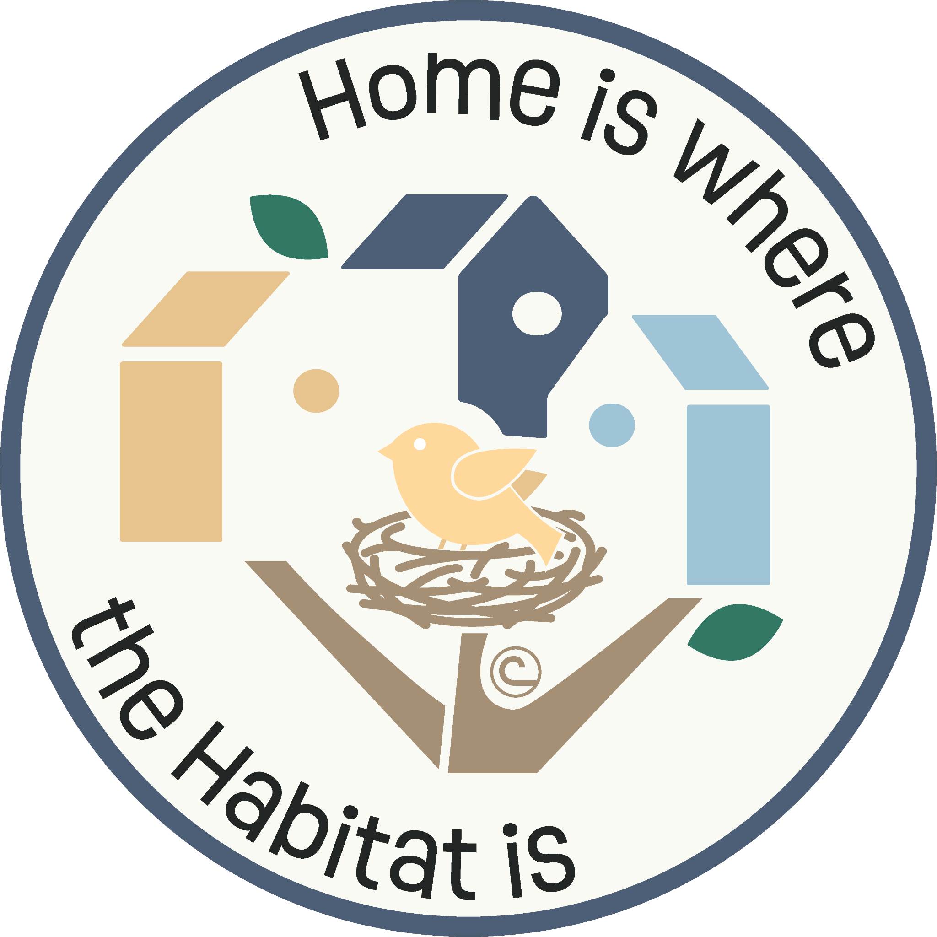

SLV Conservation Poster Contest

Quick Guide
Part of the National Association of Conservation Districts Poster Contest

Due October _4th__

Poster Instructions:
- The theme title; “Home is Where the Habitat is” must be on the poster
- Double-check spelling before using markers/colored pencils
- Must be the students’ original artwork. (individual submissions, not as a team)
- Don’t put students’ name or school on the front of the poster
- Use white 14X22’’ poster board. (regular poster board cut in half)
- Tape the entry form to the back after a parent and guardian has signed

WHAT MAKES A GOOD POSTER? - Include these poster assets:
Attracts Attention – Is simple and concise – Uses colors and white space effectively – Text is large enough to be easily read…
• A brief, catchy message; one that can be read in 10 seconds. (Theme Title Must Be Included)
•Convey a message about conservation, making the viewer care about the issue.
• Letters large enough to be easily read
• Principles of good design, good use of the entire poster area.
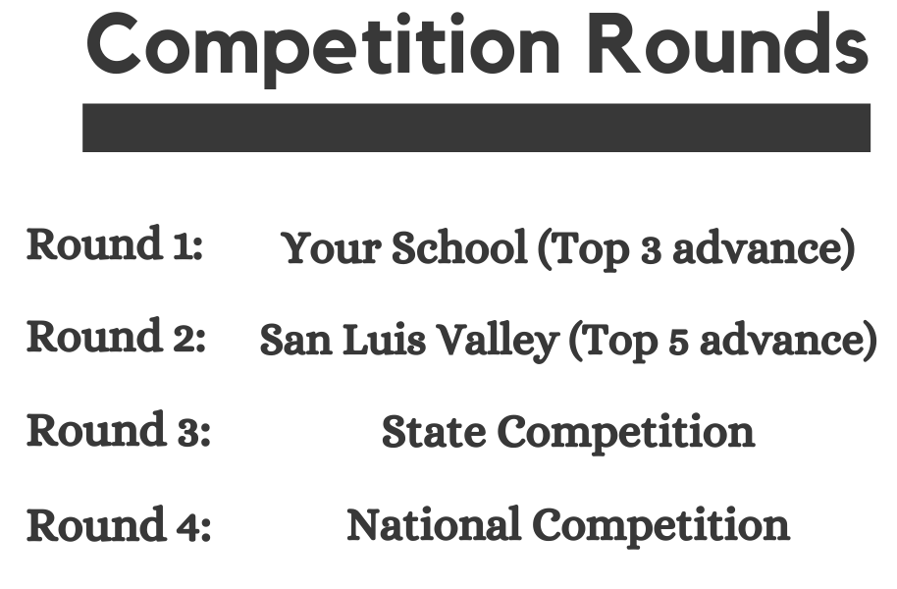
Helpful Links and topic research:
Slide Show Presentation Copy
Video- Wildlife, Colorado Open lands
Video-Riparian Areas, Colorado Open lands
Wetland Fact sheet
Chicoland Factsheet
Bird Conservancy Habitat Current Projects:

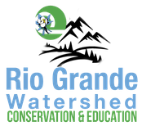
Posters will be taken to your Conservation District to be judged, and two posters per district will be submitted to the CACD (Colorado Association of Conservation Districts) competition in late October, where state winners are selected. You should hear back about winners by the end of November, and prizes will be awarded soon after. Visit rgwcei.org/postercontest for more information and to see past winning posters.

